

2506 South Elm Street

Greenville, IL 62246

[www.enertechgeo.com](http://www.enertechgeo.com)

info@enertechgeo.com

**Tech Bulletin:**

Grundfos Three-Speed Pumps

Miswired During Installation

**Rev.: 09 August 2014**

**P/N: TB14.005**

**Affected Units:**

Grundfos Three-Speed Pumps

**Discussion:**

Since the introduction of the three-speed models Enertech has noticed an unusual increase of warranty claims for the 230 VAC Grundfos pumps. We believe miswiring of the pumps is the reason for the increase due partly to the vendor’s change of the supply wire connection terminals.

The wires that were used previously have been replaced by a push-in type terminal. The terminals are labeled “L1”, “N” and  (the ground symbol). The “N” terminal is the middle terminal between “L1” and (ground symbol). In some cases the “N” terminal has been mistaken for neutral, incorrectly connecting “L2” to (ground symbol).

The pumps are manufactured in Denmark. Many European counties have 220 V 50 Hz between “L1” and “neutral”. The United States uses an electric system that utilizes 230 VAC between “L1” and “L2”, so a neutral (current carrying ground) is not needed for the 230 VAC models.

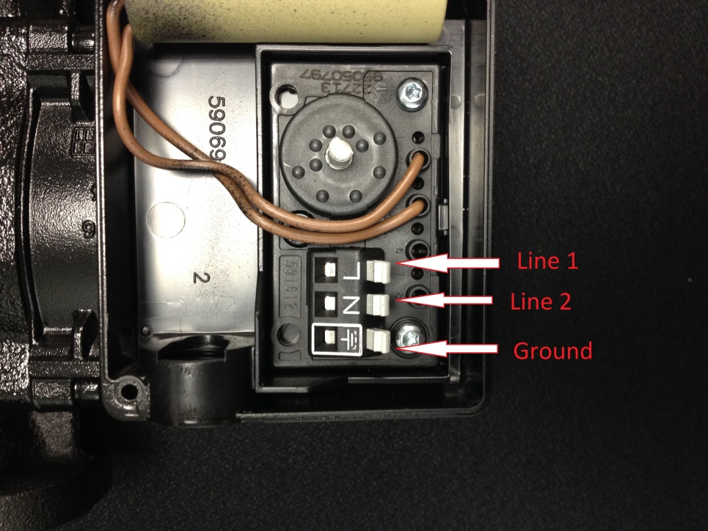Please note the international (ground symbol) as being a non-current carrying ground. It is used for grounding purposes only. “Line 1” and “Line 2” should be hooked to “L1” and “N” respectively. If you have any questions contact Technical Support. Please pass this information to installers and technicians.